MECHANICAL DESIGN MANUAL SUMMARY SHEET

SUBJECT: Fire Protection 101

DESCRIPTION: Overview of fire protection systems basics.

SPEC SECTIONS:
15310 | Fire Protection Systems
15320 | Fire Pumps

APPLICABLE CODES: NFPA 13 – 2002 – Standard for the Installation of Sprinkler Systems

NFPA 14 – 2003 – Standard for the Installation of Standpipe, Private Hydrant, and Hose Systems.

NFPA 20 – Standard for the Installation of Stationary Pumps for Fire Protection

DATE: February 2005

PREPARED BY: Fire Protection Committee
(Nathan Apprill, Brent Mannes, Tim Shimerdla & Dennis Forinash)

TABLE OF CONTENTS

pART 1 - Definitions 3
pART 2 - Project Research 5
2.1 Applicable Codes: 5
2.2 Occupancy Classification: 5
2.3 Water Utility Information: 8
2.4 Owner’s Insurance Information: 9
2.5 Authority Having Jurisdiction (AHJ): 9
PART 3 - Sprinkler systems 11
3.1 Introduction: 11
3.2 Sprinkler System Descriptions: 11
3.3 Sprinkler Descriptions 12
3.4 System Component Descriptions and Typical Usage: 16
3.5 Sprinkler Performance Characteristics: 19
3.6 Sprinkler Water Service Demand: 20
3.7 Sprinkler Spacings 21
3.8 System Protection Area Limitations: 23
3.9 Dry System Water Delivery Requirements: 24
PART 4 - Standpipe Systems 25
4.1 Introduction: 25
4.2 When standpipes are required: 25
4.3 Classes of Standpipe Systems (definitions from NFPA 14): 25
4.4 Standpipe locations: 26
4.5 Types of Standpipes: 27
4.6 Related Equipment: 28
4.7 Combined Sprinkler and Standpipe: 29
4.8 Standpipe Size, Flow, and Pressure Requirements: 29
PART 5 - Fire Pump systems 31
5.1 Introduction: 31
5.2 When Fire Pumps are Required: 31
5.3 Fire Pump Performance 31
5.4 Types of Fire Pumps 32
Fire Pump Suction Tanks: 36
PART 6 - Other Fire Protection items 37
6.1 Elevator Requirements: 37
6.2 Electrical Coordination: 38
6.3 Chemical Agent Fire Suppression 39

pART 1 - Definitions

Alarm Check Valve: A term used to describe a check valve with a waterflow-detecting alarm device.

Authority Having Jurisdiction (AHJ): Term used to describe the organization, office, or individual responsible for approving equipment, materials, an installation, or a procedure.

Combined System: A standpipe system that supplies both hose connections and automatic sprinklers.

FM Global: A research corporation used for testing and certification. Sometimes used to underwrite owner’s insurance companies. Formerly known as Factory Mutual.

Fire Pump: A pump that raises water pressure supplying a fire protection service.

FM-200: A fire-extinguishing system that discharges a clean agent chemical from fixed nozzles. Primarily used for fire protection in sensitive-equipment areas (e.g. computer rooms, data processing equipment, etc.). Used as a replacement for old Halon 1301 systems.

Gridded Sprinkler System: A sprinkler system in which parallel cross-mains are connected by multiple branch lines. An operating sprinkler will receive water from both ends of its branch line while other branch lines help transfer water between cross-mains.

Halon 1301: Halon (Bromotrifluoromethane or CBrF3) is a colorless, odorless, electrically nonconductive gas that is an effective medium for extinguishing fires. It is no longer manufactured because of its ozone depletion characteristics.

Hydraulically Designed System: A calculated sprinkler system in which pipe sizes are selected on a pressure loss basis to provide a prescribed water density, in gallons per minute per square foot, or a prescribed minimum discharge pressure or flow per sprinkler, distributed with a reasonable degree of uniformity over a specified area.

Inert Gas Agent: A clean agent fire extinguishing system that contains, as primary components, one or more of the gases helium, neon, argon, or nitrogen. Inert gas agents that are blends of gases can also contain carbon dioxide as a secondary component.

Jockey Pump: A smaller pump installed downstream of the fire pump used for pressure maintenance. It primarily keeps the fire protection system fully pressurized, keeping the much-larger fire pump from cycling on and off.

K-factor: A discharge coefficient for an orifice used in determining flow within the available pressure. It is usually used in determining sprinkler discharge. $Q=K\sqrt{p}$

Looped Sprinkler System: A sprinkler system in which multiple cross mains are tied together so as to provide more than one path for water to flow to an operating sprinkler. Branch lines are not tied together.

Nozzle Pressure: Pressure required at the inlet of a nozzle to produce the desired water discharge characteristics.

Pipe Schedule System: A sprinkler system in which the pipe sizing is selected from a schedule that is determined by the occupancy classification and in which a given number of sprinklers are allowed to be supplied from specific sizes of pipe. Pipe schedule systems are only allowed if all sprinklers have K-factors of 5.6.

Residual Pressure: Pressure acting on a point in the system while flow is being delivered.

Sprinkler System: For fire protection purposes, an integrated system of piping designed in accordance with fire protection engineering standards. The installation includes one or more automatic water supplies. The portion of the sprinkler system aboveground is a network of specially sized or hydraulically designed piping installed in a building, structure, or area, generally overhead, and to which sprinklers are attached in a systematic pattern. The valve controlling each system riser is located in the system riser or its supply piping. Each sprinkler system riser includes a device for actuating an alarm when the system is in operation. The system is usually activated by heat from a fire and discharges water over the fire area.

Standpipe System: An arrangement of piping, valves, hose connections, and associated equipment installed in a building or structure, with the hose connections located in such a manner that water can be discharged in streams or spray patterns through attached hose and nozzles, for the purpose of extinguishing a fire, thereby protecting a building or structure and its contents in addition to protecting the occupants. This is accomplished by means of connections to water supply systems or by means of pumps, tanks, and other equipment necessary to provide an adequate supply of water to the hose connections.

Static Pressure: Pressure acting on a point in the system with no flow from the system.

System Working Pressure: The maximum anticipated static (non-flowing) or flowing pressure applied to sprinkler system components exclusive of surge pressures.

pART 2 - Project Research

Applicable Codes:

  - At the beginning of each project, contact the architect, owner or local building code official to determine which codes you will be required to follow. The following codes will determine if sprinklers and standpipes are required.
    - UBC: Uniform Building Code
    - BOCA: Building Officials and Code Administrators
    - IBC: International Building Code
    - Local Jurisdiction: Occasionally colleges and universities have their own standards. You will need to contact the owner for their requirements if this is the case.

  - After determining the scope of the project and the systems that will be used, NFPA is a good source for information in designing the appropriate systems. Here are some of the frequently used codes:
    - NFPA 13 - Standard for the Installation of Sprinkler Systems
    - NFPA 14 - Standard for the Installation of Standpipe, Private Hydrant, and Hose Systems.
    - NFPA 20 – Standard for the Installation of Stationary Pumps for Fire Protection

  - Typically any building greater than three stories tall will be required to have sprinklers and standpipes, but a thorough code review is always warranted. Architectural considerations often play a role in this process.

  - Some projects include unique features: kitchens, racked storage, coolers, fuel storage, etc. Additional code research will be required for these instances.

Occupancy Classification:

  - Occupancy classifications are areas of a building with different fire hazard possibilities. The AHJ determines the occupancy classification. These areas are usually indicated on our fire protection drawings. Occupancy classifications relate to sprinkler design, installation, and water supply requirements only. They are not intended to be a general classification of occupancy hazards. Occupancy examples in the following listings in the various hazard classifications are intended to represent the norm for those occupancy types. Unusual or abnormal fuel loadings or combustible characteristics and susceptibility to changes in these characteristics for a particular occupancy are considerations that should be weighed in the selection and classification.

Most of the occupancy classifications we will encounter will fall in these three categories, as defined in NFPA 13: Light Hazard, Ordinary Hazard and Extra Hazard.

  - Light Hazard Occupancies. Light hazard occupancies are occupancies or portions of other occupancies where the quantity and/or combustibility of contents are low and fires with relatively low rates of heat release are expected. For example:
Churches
Clubs
Educational
Hospitals
Institutional
Libraries, except large stack rooms
Museums
Nursing or convalescent homes
Offices, including data processing
Residential
Restaurant seating areas
Theaters and auditoriums, excluding stages and prosceniums
Unused attics
Eaves and overhangs, if of combustible construction with no combustibles beneath

  - Ordinary Hazard Occupancies.

    - Ordinary hazard (Group 1). These are occupancies or portions of other occupancies where combustibility is low, quantity of combustibles is moderate, stockpiles of combustibles do not exceed 8 ft (2.4 m), and fires with moderate rates of heat release are expected. For example:
Automobile parking and showrooms
Bakeries
Beverage manufacturing
Canneries
Dairy products manufacturing and processing
Electronic plants
Glass and glass products manufacturing
Laundries
Restaurant service areas

    - Ordinary Hazard (Group 2). These are occupancies or portions of other occupancies where the quantity and combustibility of contents is moderate to high, stockpiles do not exceed 12 ft (3.7 m), and fires with moderate to high rates of heat release are expected. For example:
Cereal mills
Chemical plants — ordinary
Confectionery products
Distilleries
Dry cleaners
Feed mills
Horse stables
Leather goods manufacturing
Libraries — large stack room areas
Machine shops
Metalworking
Mercantile
Paper and pulp mills
Paper process plants
Piers and wharves
Post offices
Printing and publishing
Repair garages
Resin application area
Stages
Textile manufacturing
Tire manufacturing
Tobacco products manufacturing
Wood machining
Wood product assembly

  - Extra Hazard Occupancies.

    - Extra Hazard (Group 1). These are occupancies or portions of other occupancies where the quantity and combustibility of contents is very high and dust, lint, or other materials are present, introducing the probability of rapidly developing fires with high rates of heat release but with little or no combustible or flammable liquids. For example:
Aircraft hangars (except as governed by NFPA 409, Standard on Aircraft Hangars)
Combustible hydraulic fluid use areas
Die casting
Metal extruding
Plywood and particleboard manufacturing
Printing [using inks having flash points below 100°F (38°C)]
Rubber reclaiming, compounding, drying, milling, vulcanizing
Sawmills
Textile picking, opening, blending, garneting, or carding, combining of cotton, synthetics, wool shoddy, or burlap
Upholstering with plastic foams

    - Extra Hazard (Group 2). These occupancies shall include occupancies with moderate to substantial amounts of flammable or combustible liquids or occupancies where shielding of combustibles is extensive. For example:
Asphalt saturating
Flammable liquids spraying
Flow coating
Manufactured home or modular building assemblies (where finished enclosure is present and has combustible interiors)
Open oil quenching
Plastics processing
Solvent cleaning
Varnish and paint dipping

Water Utility Information:

  - At the beginning of each project, contact the local water company to exchange important information:

    - Give the water utility company the address and/or location of the proposed system.
    - Ask for static, residual, and associated flow for the fire hydrants in this area.
    - Request a hydrant flow test if the information is not available or out of date.

  - If the utility is unwilling or cannot do a hydrant flow test, require that the contractor perform a hydrant flow test.

If you have access to this information, you’ll want to include the “Fire Hydrant Flow Test CAD block” on your fire protection construction documents, which summarizes the information from the local water company. There is a long form and a short form.

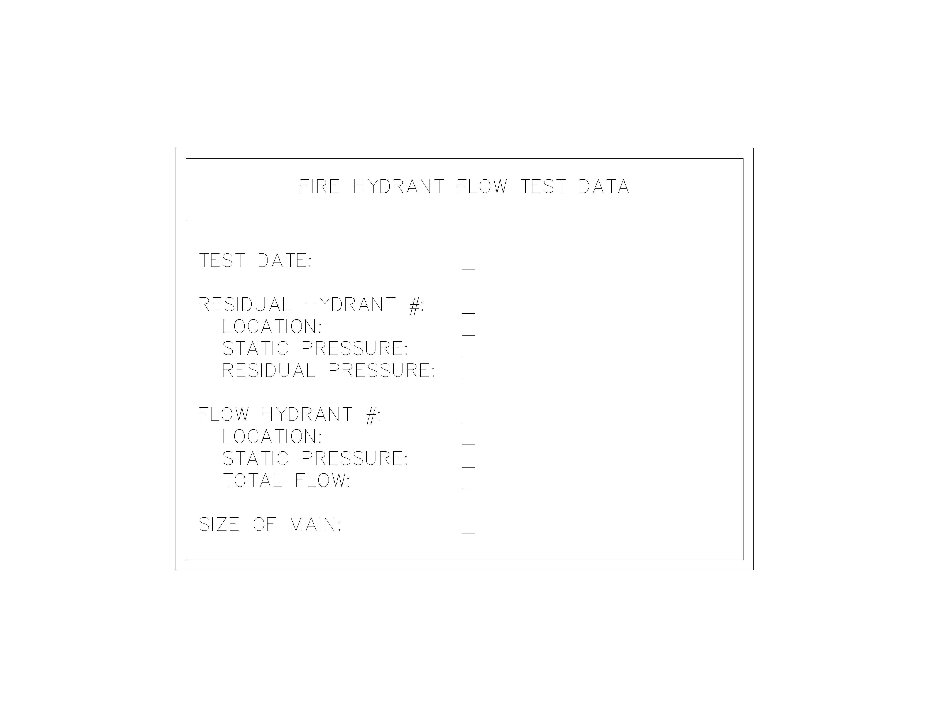
The long form of the fire hydrant flow test block in CAD.

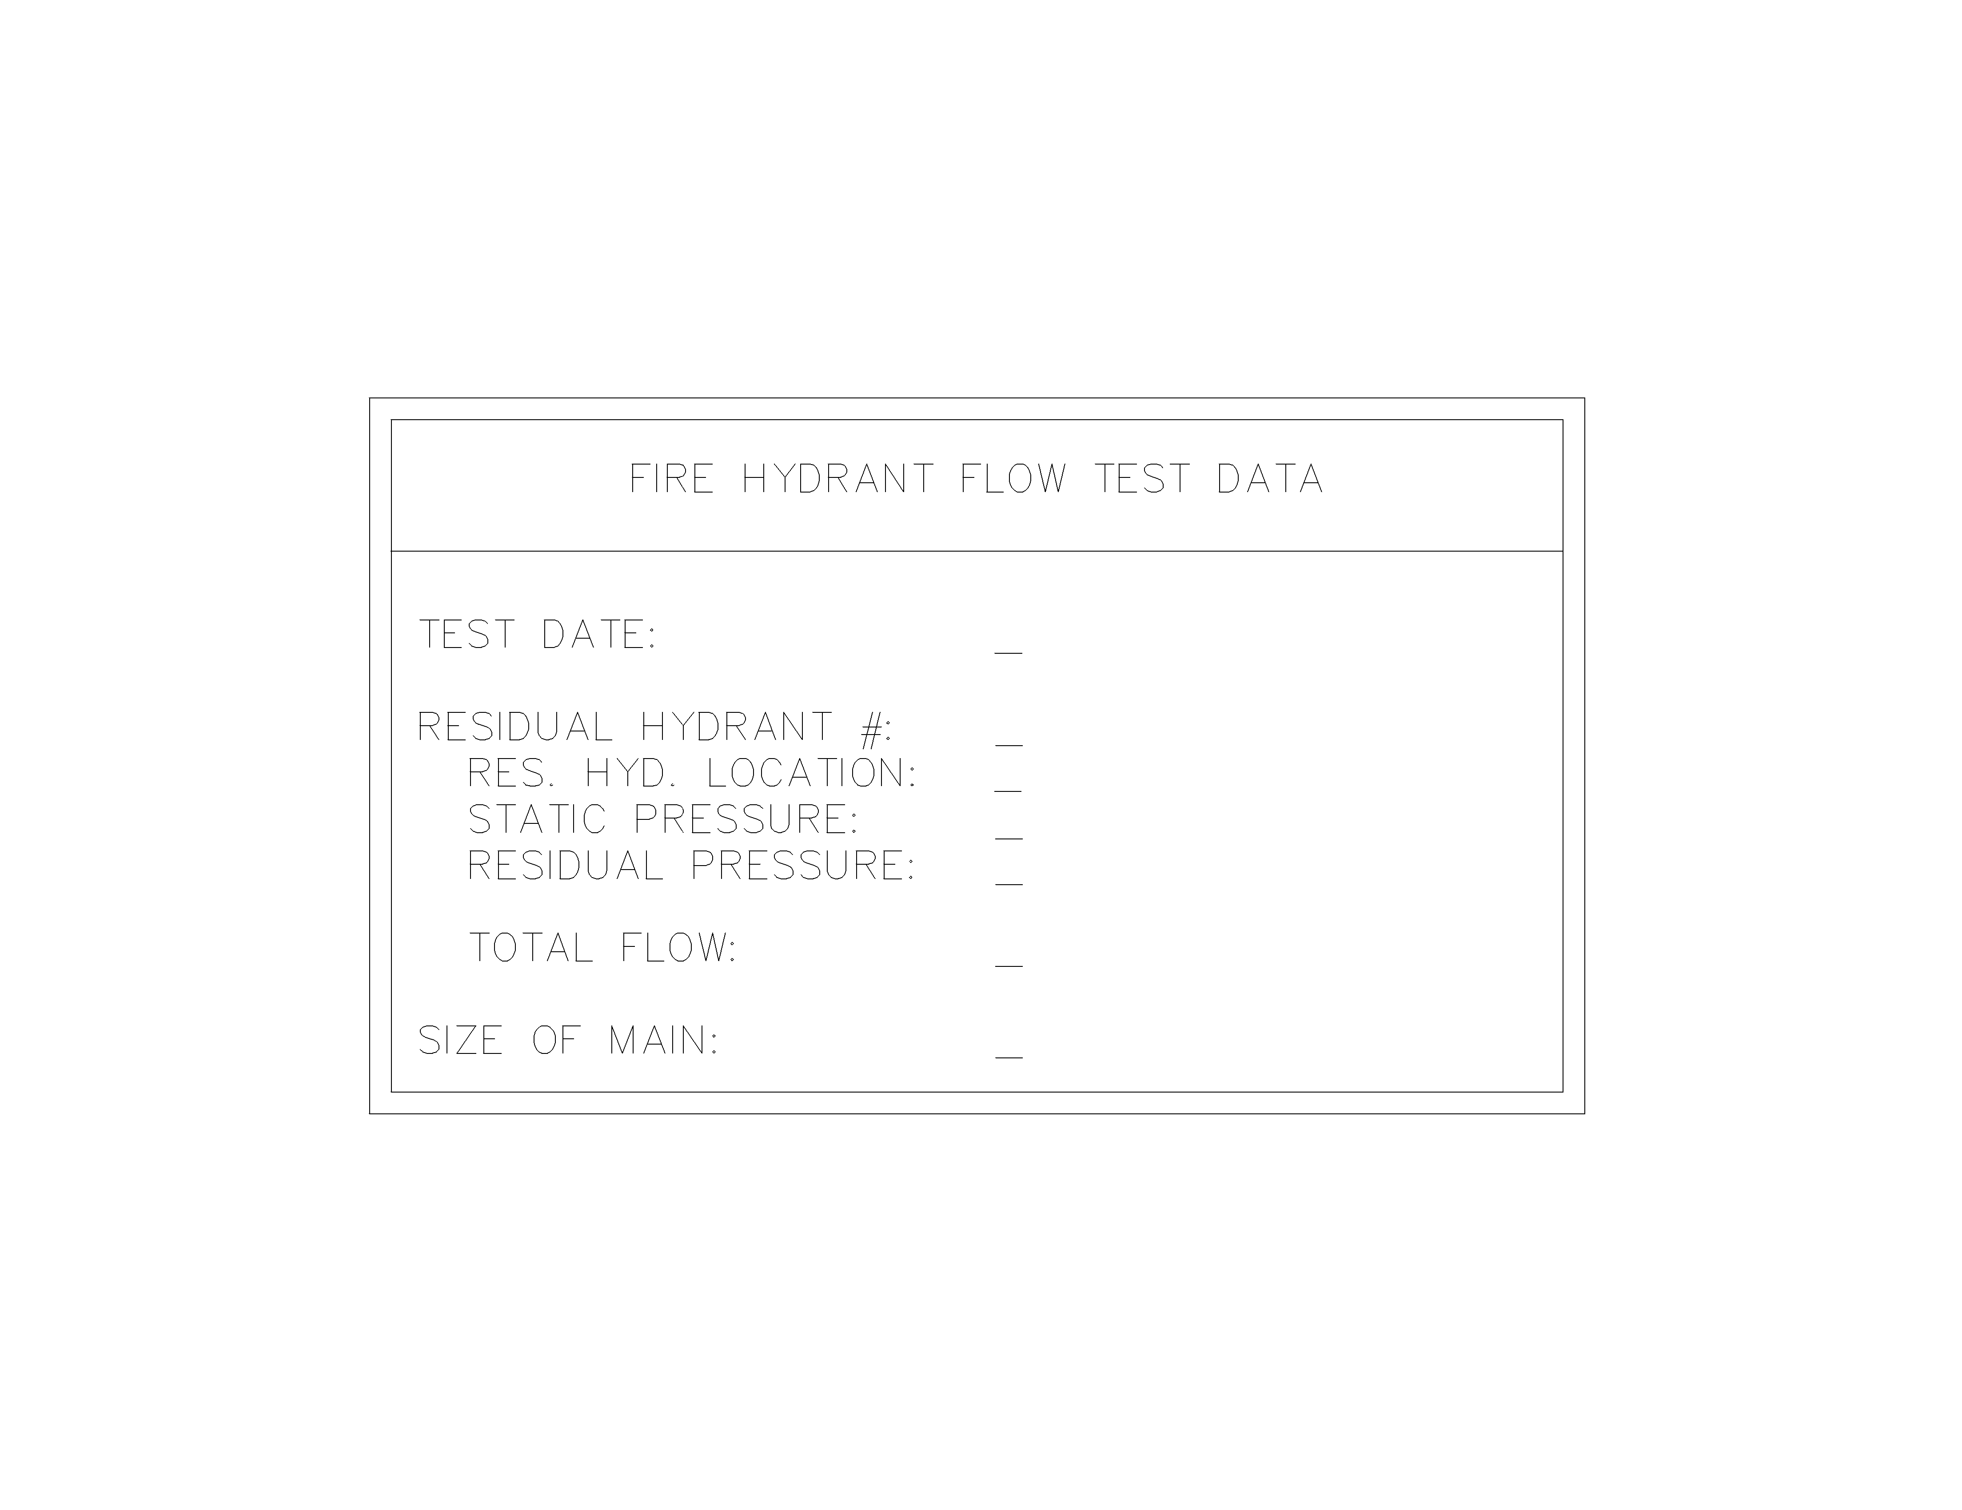
The short form of the fire hydrant flow test block in CAD.

Owner’s Insurance Information:

  - Inform the owner that you plan to contact their insurance company. Some things to discuss with the owner or insurance carrier:
    - Any special requirements above NFPA?
    - Any rooms that will require a special hazard requirement?
    - FM requirements: It is important early on to find out whether the owner is insured by FM Global. If so, contact their FM representative to see if they have any requirements relating to the fire protection design. KJWW – Rock Island has the complete set of FM Global standards and bulletins.

  - Some insurance companies will determine sprinkler densities, hazard classifications, and hose stream along with a complete risk assessment. Insurance companies that typically get involved doing design are:
    - FM Global (FM)
    - Zurich-American Insurance
    - Employees Mutual Company (EMC Insurance Co.)
    - Industrial Risk Insurance (IRI)
    - Royal & Sun Alliance

Authority Having Jurisdiction (AHJ):

  - The phrase “authority having jurisdiction” is used in NFPA documents in a broad manner, since jurisdictions and approval agencies vary, as do their responsibilities. Where public safety is primary, the authority having jurisdiction may be a federal, state, local, or other regional department or individual such as a fire chief; fire marshal; chief of a fire prevention bureau, labor department, or health department; building official; electrical inspector; or others having statutory authority. For insurance purposes, an insurance inspection department, rating bureau, or other insurance company representative may be the authority having jurisdiction. In many circumstances, the property owner or his or her designated agent assumes the role of the authority having jurisdiction; at government installations, the commanding officer or departmental official may be the authority having jurisdiction.

PART 3 - Sprinkler systems

Introduction:
  - The intent of this guideline is to give background information on the most common sprinkler systems and applications. A description of the basic system components that are in the fire protection material list is included. Commonly used tables with basic design information are also included.

Sprinkler System Descriptions:
  - Below are brief descriptions and typical applications of the most common sprinkler systems.
    - Wet Pipe Sprinkler Systems: The sprinklers in these systems are attached to pipes containing pressurized water at all times. Individual sprinklers in the vicinity of a fire are activated by heat, allowing water to flow through them immediately. Wet-pipe systems are used wherever temperatures are high enough to prevent freezing.
      - Typical Applications: Offices, schools, most applications.
    - Antifreeze Sprinkler System: Similar to a Wet Pipe Sprinkler System, the system is initially filled with an antifreeze solution. Upon operation of the sprinkler system, the antifreeze solution is discharged, followed by water. This system is used in systems where freezing is a possibility.
      - Typical Applications: Small area, minimum number of sprinklers served, potential of freezing system exists. Normally, KJWW would design a dry pipe system for this application.
    - Dry Pipe Sprinkler System: In a dry-pipe system, sprinklers are attached to pipes that contain pressurized air. When heat activates the sprinklers, the air pressure is reduced, allowing the dry pipe valve to open and water to flow to the sprinkler. Dry-pipe systems are usually used only when temperatures are not high enough to prevent freezing (Below 40 deg. F). In situations where only a few sections lack heat, it is recommended to use a combination of dry and wet-pipe systems.
      - Typical Applications: Attics, unheated areas, covered docks or awnings. Potential of freezing system exists. Any non-heated indoor space.
    - Preaction Systems: These systems contain an additional fire-detection device that will recognize a fire before water will be released to the sprinklers. There are single and double interlock preaction systems.
The single interlock preaction system (SIPS) will have air at atmospheric pressure in the system piping. Activation of a smoke or heat detector will release the water for the system. When a sprinkler activates, the air in the pipe will be forced out through the sprinkler followed by the water that has been released.

The double interlock preaction system (DIPS) will have pressurized air in the system piping. The DIPS will require a loss of air pressure in the system as well as activation of a smoke or heat detector for water to be released into the system. The loss of air pressure in the system signifies that at least one sprinkler has activated.
Preaction systems are usually employed in areas that are at risk for serious water damage due to damaged sprinklers and/or piping.
Of the two, the double interlock preaction system is more common.
      - Typical Applications: Freezers, data centers, computer rooms and large electric rooms.
    - Deluge Sprinkler System: In these systems, sprinklers are open all of the time. They are connected to a dry pipe that is connected to a main water supply. A fire detection device controls the main valve. When it is activated, the valve opens, allowing large amounts of water to flow through all of the sprinklers. The purpose of a deluge system is to quickly wet down an entire hazardous area to prevent a fire from spreading.
      - Typical Applications: Facilities that contain high or extra hazard materials such as: flammable liquids, chemicals, and explosives. Rooms with high ceilings sometimes use deluge systems, as it is difficult to direct water over the burning area from such a distance.
- Sprinkler Descriptions:
  - Classified by Design and Performance Characteristics:
    - Early Suppression Fast-Response (ESFR) Sprinkler: A type of fast-response sprinkler (Response Time Index < 50) that is listed for its capability to provide fire suppression of specific high-challenge fire hazards. Normally these are used in storage facilities.
    - Extended Coverage Sprinkler: A type of spray sprinkler with larger maximum coverage areas as specified in NFPA 13.
    - Large Drop Sprinkler: A type of sprinkler that is capable of producing characteristic large water droplets and that is listed for its capability to provide fire control of specific high-challenge fire hazards. Larger drops are more able to penetrate to the base of the fire.
    - Old-Style/Conventional Sprinkler: A sprinkler that directs from 40 percent to 60 percent of the total water initially in a downward direction and is designed to be installed with the deflector either upright or pendent.
    - Open Sprinkler: A sprinkler that does not have actuators or heat-responsive elements. Used in deluge sprinkler systems.
    - Quick-Response Early Suppression (QRES) Sprinkler: A type of quick-response sprinkler that is listed for its capability to provide fire suppression of specific fire hazards. These are still being developed as of May 2004.
    - Quick-Response (QR) Sprinkler: A type of sprinkler that is listed as a quick-response sprinkler for its intended use. Required for all light hazard occupancy.
    - Residential Sprinkler: A type of fast-response sprinkler that meets the criteria of NFPA 13 or 13R that has been specifically investigated for its ability to enhance survivability in the room of fire origin and is listed for use in the protection of dwelling units.
    - Special Sprinkler: A sprinkler that has been tested and listed as prescribed in NFPA 13. An example is Central’s window sprinkler.
    - Standard Response vs. Fast Response vs. Quick Response Sprinklers – What is the difference? Fast response sprinklers utilize a fast response element, which will respond more quickly to a fire than will a standard response sprinkler. Fast response sensing elements have an RTI of 50 or less, per NFPA 13, and can utilize either glass bulbs or fusible elements. However, in order for a sprinkler to be UL Listed as a quick response sprinkler, it has to use a fast response element and it also has to operate within 75 seconds in the room fire test. Therefore, the quick response sprinkler is even more sensitive than, and will react more rapidly to a fire condition, than a fast response sprinkler.
  - Classified According to Orientation:
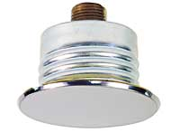

    - Concealed Sprinkler: A recessed sprinkler with a cover plate.

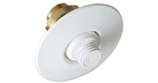
    - Flush Sprinkler: A sprinkler in which all or part of the body, including the shank thread, is mounted above the lower plane of the ceiling.

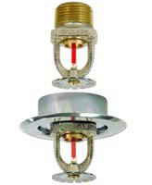

    - Pendant Sprinkler: A sprinkler designed to be installed in such a way that the water stream is directed downward against the deflector.

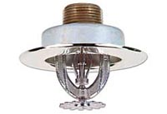

    - Recessed Sprinkler: A sprinkler in which all or part of the body, other than the shank thread, is mounted within a recessed housing.

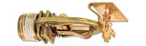
    - Sidewall Sprinkler: A sprinkler having special deflectors that are designed to discharge most of the water away from the nearby wall in a pattern resembling one-quarter of a sphere, with a small portion of the discharge directed at the wall behind the sprinkler.

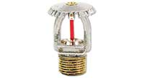
    - Upright Sprinkler: A sprinkler designed to be installed in such a way that the water spray is directed upwards against the deflector.

  - Classified According to Special Applications or Environment:
    - Corrosion-Resistant Sprinkler: Sprinklers fabricated with corrosion-resistant material or with special coatings or platings to be used in an atmosphere that would normally corrode sprinklers.

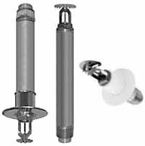
    - Dry Sprinkler: A sprinkler secured in an extension nipple that has a seal at the inlet end to prevent water from entering the nipple until the sprinkler operates. These are often used for walk-in freezers to avoid having to use dry-pipe systems.

    - Intermediate Level Sprinkler/Rack Storage Sprinkler: A sprinkler equipped with integral shields to protect its operating elements from the discharge of sprinklers installed at higher elevations.
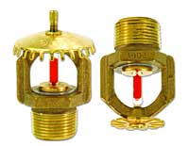
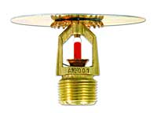
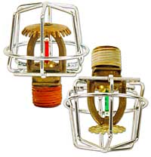

    - Ornamental/Decorative Sprinkler: Sprinklers that have been painted or plated by the manufacturer.

  - Classified According to Sprinkler Finish:
    - Sprinklers and sprinkler covers come in various different finish types. Each manufacturer and sprinkler type will have different finishes available. Verify finishes available, especially when unique finishes are used. Several of the more common finishes are as follows:
      - Sprinkler finishes: brass, bright brass, chrome, white and black.
      - Sprinkler cover plates: bright brass, antique brass, polished chrome, brushed chrome, brushed copper, painted white, painted ivory, and painted black.
    - Sprinkler frames shall be permitted to be factory painted or enameled as ornamental finish in accordance with NFPA; otherwise, sprinklers shall not be painted, and any sprinklers that have been painted shall be replaced with new, listed sprinklers.

- System Component Descriptions and Typical Usage:
All of the items described below are listed in the fire protection material list.
  - Accelerators – NFPA 13 defines these as “Quick-Opening Devices”. Accelerators are used on dry pipe systems to speed the operation of the dry pipe valve. Accelerators are mounted with the dry-pipe valve trim. They release large quantities of compressed air when the dry pipe valve is tripped. Quick opening devices are required on systems over 500 gallons.
  - Air Pressure Maintenance Device - A pressure regulator with bypass, used on dry pipe and preaction systems where an air compressor or plant air supplies compressed air. The regulator is generally preset to maintain 40 psig. A small restriction prevents rapid re-pressurization of the system. The bypass is used to initially fill the system with compressed air. An air pressure maintenance device is not used when a small maintenance air compressor is used.
  - Air Pressure Supervisory Switch – A pressure switch installed in the compressed air piping to monitor the air supply for dry systems. For dry pipe systems, the fire alarm panel monitors this for a trouble condition. For double interlocked preaction systems, the system release panel uses the pressure switch as one of the two required conditions to release the deluge valve.
  - Automatic Drip Valve – A spring loaded ball drip valve used to automatically drain a pipe. When the pipe comes under pressure, the valve closes. Typically used between the fire department connection and the check valve. NFPA 13 only requires automatic drip valves in areas subject to freezing.
  - Deluge Valve – A quick opening flood valve used in deluge and preaction systems. The valve is held closed by system water pressure in a priming chamber. The valve is released by releasing the water pressure from the priming chamber.
  - Dry Pipe Valve – A mechanical differential pressure valve that keeps water out of dry sprinkler pipes. The valve clapper is held closed (typically with 40 psig air) as long as the air pressure exerts a greater force on the top side of the clapper than the water pressure below. The area of the air seat is much larger than the water seat, so the air pressure needed to keep the valve closed is only a fraction of the water pressure. Once the clapper has been opened, the clapper can only be manually reset to its closed position with a dry valve-resetting tool.
  - Electric Bells – Electric bells are located on the exterior of the building near the fire department connection. Their purpose is to help the fire department locate the fire department connection. A horn-strobe can also be used instead of the bell, but needs to be coordinated with the authority having jurisdiction.
  - Fire Department Connection – Fire department connections are used by the fire department to connect the fire truck up to the fire protection system. The typical size of the connections is 2-1/2”. The three typical types typically specified are:
    - Exposed – A two- or three-way wye fitting located on the outside of the building.
    - Flush – A two (or up to eight) way wye fitting that is concealed in the wall with only the caps exposed.
    - Free Standing – A freestanding fire department connection used on exterior fire lines piped vertically to grade. This requires a basement or pit to allow for draining of the system.
  - Fire Pump Test Connection (Also referred to as a Hose Header) – An assembly consisting of a pipe header, gate valves with hose connections and caps to be used to test a fire pump system. Each valve and hose connection is rated for 250 gpm, which determines the number of valves required based on system capacity.
  - Flow Switch – Water flow switch in a wet pipe sprinkler system to determine when water is flowing. Typically located at the system main and at each sprinkler zone in a building.
  - Hose Valves – Used in a standpipe system to allow the fire department to tap off of standpipes with 2-1/2” hoses for Class I, 1-1/2” hoses for Class II and both for Class III. Come in multiple configurations depending on the application. Most commonly used are as follows:
    - Straight
    - Angle
    - Pressure Regulating – Used on high-pressure standpipes to regulate the water pressure to a set pressure between 100 and 175 psi.
    - Two-way Roof – Used when a rooftop hose valve is required.
    - Pressure Restricting - (Not typically specified by KJWW) Used on high pressure standpipes to restrict outlet water pressure using a fixed orifice.
  - Indicator Posts – Used in conjunction with gate valve, GA-9 to give a visual position indication of the valve. The indicator post is also used to open and close the valve. The most commonly used are as follows:
    - Free Standing – Located remote from the building used for underground gate valves. Appendix (A.8.15.1.3) lists 40 foot preferred minimum distance from building.
    - Wall – Located on the exterior wall of the building. It should be a “blank wall where the possibility of injury by falling walls is unlikely and from which people are not likely to be driven by smoke or heat.”
  - Inspector Test Station – Includes a test and drain valve with integral sight glass, ball valve with integral labeled plate showing test drain position. Furnished with test orifice giving flow equivalent to one sprinkler of the type having the smallest orifice installed in the system.
    - Wet Pipe Sprinkler System – For a typical wet pipe sprinkler system this will be located downstream of the zone flow switch and will be used to test the operation of the flow switch. Some jurisdictions require that this be located at the most remote sprinkler in the system. This needs to be verified for each project or jurisdiction.
    - Dry Pipe Sprinkler System – For a typical dry pipe sprinkler system this will need to be located at the most remote sprinkler and will be used not only to test the operation of the system, but also to test if the time required for water to reach the sprinkler is within the acceptable range.
  - Maintenance Air Compressor – A small air compressor that straps on the main sprinkler entrance riser pipe to maintain air pressure in dry pipe or preaction systems. This compressor is used when plant air is considered unreliable or plant air is not on emergency power. This compressor could be used as the sole air supply, if the system is very small (i.e. can be filled in 30 minutes or less).
  - Monitor Switches – Used by the fire alarm system to monitor shut-off valve position.
  - Pressure Switch – An electric alarm-initiating device that can be used in wet, dry, preaction, or deluge systems. KJWW specifies pressure switches for alarm annunciation of dry-pipe and preaction systems. The pressure switch is installed in the dry-pipe or preaction piping assembly.
  - Retarding Chamber – A surge tank used with an alarm check valve to reduce the possibility of false alarms due to sudden changes in water pressure. Water is piped through the retarding chamber to either a pressure switch or a water motor alarm and water gong.

Sprinkler Performance Characteristics:
(Tables Taken From NFPA 13-2002)
  - Sprinkler Temperature Ratings Classifications, and Color Codings:
Max. Ceiling Temp. | Temperature Rating | Temperature Classification | Color Code | Glass Bulb Colors
^{º}F | ^{º}F | Temperature Classification | Color Code | Glass Bulb Colors
100 | 135-170 | Ordinary | Uncolored or Black | Orange or Red
150 | 175-225 | Intermediate | White | Yellow or Green
225 | 250-300 | High | Blue | Blue
300 | 325-375 | Extra High | Red | Purple
375 | 400-475 | Very Extra High | Green | Black
475 | 500-575 | Ultra High | Orange | Black
625 | 650 | Ultra High | Orange | Black

  - Sprinkler “K” Factors: Also known as the orifice constant, determines the relationship between the flow rate, Q (gpm) and the normal pressure, p (psi).
$$Q=K\sqrt{p}$$
  - Sprinkler Discharge Characteristics Identification
Nominal  K-factor  gpm/(psi)^{0.5} | K-factor  Range  gpm/(psi)^{0.5} | Percent of  Nominal K-5.6 Discharge | Thread Type
1.4 | 1.3 – 1.5 | 25 | ½ in NPT
1.9 | 1.8 – 2.0 | 33.3 | ½ in NPT
2.8 | 2.6 – 2.9 | 50 | ½ in NPT
4.2 | 4.0 – 4.4 | 75 | ½ in NPT
5.6 (standard) | 5.3 – 5.8 | 100 | ½ in NPT
8.0 | 7.4 – 8.2 | 140 | ¾ in NPT or ½ in NPT
11.2 | 11.0 –11.5 | 200 | ½ in NPT or ¾ in NPT
14.0 | 13.5 – 14.5 | 250 | ½ in NPT
16.8 | 16.0 – 17.6 | 300 | ½ in NPT
19.6 | 18.6 – 20.6 | 350 | ½ in NPT
22.4 | 21.3 – 23.5 | 400 | ½ in NPT
25.2 | 23.9 – 26.5 | 450 | ½ in NPT
28.0 | 26.6 – 29.4 | 500 | ½ in NPT

Sprinkler Water Service Demand:
Several factors are used to determine the water service requirements for sprinkler systems. Below are several tools to help determine these requirements. Refer to the Fire Protection Main Sizing Mechanical Design Memo for additional information.
  - Sprinkler Density Chart: This chart is used to help determine the water supply requirements for sprinklers.
    - For dry pipe and double interlock preaction systems, the area shall be increased by 30% without revising the density.

Area/density curves

  - Hose Stream Demand and Water Supply Duration Requirements for Hydraulically Calculated Systems
Occupancy or Commodity Classification | Inside Hose (gpm) | Total Combined Inside and Outside Hose (gpm) | Duration (minutes)
Light Hazard | 0, 50 or 100 | 100 | 30
Ordinary Hazard | 0, 50 or 100 | 250 | 60-90
Extra Hazard | 0, 50 or 100 | 500 | 90-120

  - Pressures for Sprinkler (Minimum and range of PSI for sprinklers)
    - 7 psi code minimum. Every sprinkler has a listed minimum pressure, which could be higher than 7 psig.
- Sprinkler Spacings:
Below are tables taken from NFPA 13 listing the protection area and maximum spacing allowed for different construction types when different types of sprinklers are used.
  - Standard Spray Upright/Standard Spray Pendent - Light Hazard
Construction Type | System Type | Protection Area | Spacing (maximum)
Construction Type | System Type | ft² | Ft
Noncombustible obstructed and unobstructed and combustible unobstructed | Pipe Schedule | 200 | 15
 | Hydraulically Calculated | 225 | 15
Combustible obstructed | All | 168 | 15
Combustible with members less than 3 ft on center | All | 130 | 15

  - Standard Spray Upright/Standard Spray Pendent - Ordinary Hazard
Construction Type | System Type | Protection Area | Spacing (maximum)
Construction Type | System Type | ft² | ft
All | All | 130 | 15

  - Standard Spray Upright/Standard Spray Pendent - Extra Hazard
Construction Type | System Type | Protection Area | Spacing (maximum)
Construction Type | System Type | ft² | ft
All | Pipe Schedule | 90 | 12*
All | Hydraulically calculated with density ≥ 0.25 | 100 | 12*
All | Hydraulically calculated with density ≤ 0.25 | 130 | 15
*In buildings with storage bays 25 ft wide, 12 ft 6 in. shall be permitted.

  - Standard Sidewall Spray Sprinkler
 | Light Hazard |  | Ordinary Hazard
 | Combustible finish | Noncombustible or limited combustible finish | Combustible finish | Noncombustible or limited combustible finish
Maximum distance along the wall (S) | 14 ft | 14 ft | 10 ft | 10 ft
Maximum room width (L) | 12 ft | 14 ft | 10 ft | 10 ft
Maximum protection area | 120 ft² | 196 ft² | 80 ft² | 100 ft²

  - Extended Coverage Upright and Pendant Spray Sprinklers
Construction Type | Light Hazard |  | Ordinary Hazard |  | Extra Hazard |  | High-Piled Storage
Construction Type | Protection Area (ft²) | Spacing (ft) | Protection Area (ft²) | Spacing (ft) | Protection Area (ft²) | Spacing (ft) | Protection Area (ft²) | Spacing (ft)
Unobstructed | 400 | 20 | 400 | 20 | - | - | - | -
Unobstructed | 324 | 18 | 324 | 18 | - | - | - | -
Unobstructed | 256 | 16 | 256 | 16 | - | - | - | -
Unobstructed | - | - | 196 | 14 | 196 | 14 | 196 | 14
Unobstructed | - | - | 144 | 12 | 144 | 12 | 144 | 12
Obstructed | 400 | 20 | 400 | 20 | - | - | - | -
Noncombustible (when specifically listed for such use) | 324 | 18 | 324 | 18 | - | - | - | -
Noncombustible (when specifically listed for such use) | 256 | 16 | 256 | 16 | - | - | - | -
Noncombustible (when specifically listed for such use) | - | - | 196 | 14 | 196 | 14 | 196 | 14
Noncombustible (when specifically listed for such use) | - | - | 144 | 12 | 144 | 12 | 144 | 12
Obstructed Combustible | N/A | N/A | N/A | N/A | N/A | N/A | N/A | N/A

  - Extended Coverage Sidewall
Construction Type | Light Hazard |  | Ordinary Hazard
Construction Type | Protection Area | Spacing | Protection Area | Spacing
Construction Type | ft² | ft | ft² | ft
Unobstructed, smooth, flat | 400 | 28 | 400 | 24

  - Large Drop Sprinklers
Construction Type | Protection Area | Maximum Spacing
 | ft² | ft
Noncombustible unobstructed | 130 | 12
Noncombustible obstructed | 130 | 12
Combustible unobstructed | 130 | 12
Combustible obstructed | 100 | 10
Rack Storage applications | 100 | 10

  - ESFR Sprinklers
Construction Type | Ceiling/Roof Heights  up to 30 ft |  | Ceiling/Roof Heights  over 30 ft
Construction Type | Protection Area | Maximum Spacing | Protection Area | Maximum Spacing
Construction Type | ft² | ft | ft² | ft
Noncombustible unobstructed | 100 | 12 | 100 | 10
Noncombustible obstructed | 100 | 12 | 100 | 10
Combustible unobstructed | 100 | 12 | 100 | 10
Combustible obstructed | N/A | N/A | N/A | N/A

System Protection Area Limitations:
The maximum floor area on any one floor to be protected by sprinklers supplied by any one sprinkler system riser or combined system riser shall be as follows:
  - Light Hazard – 52,000 ft²
  - Ordinary Hazard – 52,000 ft²
  - Extra Hazard –
    - Pipe Schedule – 25,000 ft²
    - Hydraulically Calculated – 40,000 ft²
  - Storage – High piled storage and storage covered by other NFPA standards – 40,000 ft²

Dry System Water Delivery Requirements:
Dry pipe valves can serve systems with a volume of up to 750 gallons of system volume. Systems can exceed 750 gallons if water is delivered to the Inspector’s test connection in 60 seconds or less and water is delivered to sprinklers in accordance with the following table:

Hazard | Number of Most Remote Sprinklers Initially Open | Maximum Time of Water Deliver
Residential | 1 | 15 seconds
Light | 1 | 60 seconds
Ordinary I | 2 | 50 seconds
Ordinary II | 2 | 50 seconds
Extra I | 4 | 45 seconds
Extra II | 4 | 45 seconds
High Piled | 4 | 40 seconds

PART 4 - Standpipe Systems

Introduction:

  - A standpipe is a fire protection piping system that delivers water to hose connections (and sprinklers on combined systems). Standpipe design is governed by building height, area per floor, occupancy classification, required exit stairs, required flow rate and residual pressure, and the distance of the hose connection from the source(s) of the water supply.

When standpipes are required:

  - The applicable building code, usually UBC or IBC, determines if standpipes are required. UBC (1997) Chapter 3, Section 301 sets forth several occupancy groups, while Table 3-A at the end of the chapter describes those different occupancies in some detail. Once the occupancy classification of your building has been determined, see Chapter 9, Section 904, 904.5.2. You will be referred to Table 9-A (again, at the end of the chapter), which spells out what standpipe classes are necessary for different occupancies, whether sprinklered or not. The 2003 IBC spells out standpipe requirements in Section 905.

  - Always discuss standpipes with the AHJ. Many fire chiefs believe that 1-1/2” hoses result in occupants trying to fight fire when in fact, they should dial 911. The AHJ may waive a requirement for 1-1/2” hose connections.

Classes of Standpipe Systems (definitions from NFPA 14):

  - Class I Systems: A Class I standpipe system shall provide 2½” hose connections (just hose connections – no hose) to supply water for use by fire departments and those trained in handling heavy fire streams.

  - Class II Systems: A Class II standpipe system shall provide 1½” hose stations (racks or cabinets with connections and hoses) to supply water for use primarily by the building occupants or by the fire department during initial response.
    - Exception: A minimum 1” hose shall be permitted to be used for hose stations in light hazard occupancies where investigated and listed for this service and where approved by the AHJ.

  - Class III Systems: A Class III standpipe system shall provide 1½” hose stations to supply water for use by building occupants and 2½” hose connections to supply a larger volume of water for use by fire departments and those trained in handling heavy fire streams.
    - Exception No. 1: A minimum 1” hose shall be permitted to be used for hose stations in light hazard occupancies where investigated and listed for this service and where approved by the AHJ.
    - Exception No. 2: Where the building is protected throughout by an approved automatic sprinkler system, hose stations for use by the building occupants shall not be required, subject to the approval of the AHJ, provided that each hose connection is 2½” and is equipped with a 2½” x 1½” reducer and a cap attached with a chain.

Standpipe locations:

  - In general, standpipes run vertically, either exposed in stairways or in chases within stairways, with one hose valve or hose cabinet (depending on standpipe class) per floor. Each exit stairway (required by code) for building egress must have its own standpipe. Fire chiefs may have requirements for valve locations also. The following are more in-depth descriptions of standpipe locations:

  - Class I Systems: Class I systems shall be provided with 2½” hose connections in the following locations (according to NFPA 14):

    - At each intermediate landing between floor levels in every required exit stairway.
      - Exception: Hose connections shall be permitted to be located at the main floor landings in exit stairways where approved by the AHJ.

Note: UBC states that hose connections will be located at the main floor landings – the exception according to NFPA. Check with the AHJ to see where to locate hose connections.

    - On each side of the wall adjacent to the exit openings of horizontal exits.

Note: Check with the architect to see if any required “horizontal exits” are present. If so, hose connections are required, both inside and outside, on the wall that includes the exit door.

    - In each exit passageway at the entrance from the building areas into the passageway. (Again, check with the architect.)

    - In covered mall buildings, at the entrance to each exit passageway or exit corridor, and at exterior public entrances to the mall. (Again, check with the architect.)

    - At the highest landing of stairways with stairway access to a roof and on the roof where stairways do not access the roof. An additional 2½” hose connection shall be provided at the hydraulically most remote riser to facilitate testing of the system.

Note: This appears to contradict NFPA’s requiring hose valves at intermediate stair landings, rather than at floor-level landings. It begs the question, then, whether or not a connection is required at the intermediate landing just below the highest landing (presumably at roof level) with roof access. Consult the AHJ.

    - Additional hose connections shall be provided, in approved locations, where required by the local fire department or the AHJ in the following locations:
      - Where the most remote portion of a nonsprinklered floor or story is located in excess of 150’ of travel distance from a required exit containing or adjacent to a hose connection.
      - Where the most remote portion of a sprinklered floor or story is located in excess of 200’ of travel distance from a required exit containing or adjacent to a hose connection.

  - Class II Systems: Class II systems shall be provided with 1½” hose stations so that all portions of each floor level of the building are within 130’ of a hose connection provided with 1½” hose or within 120’ of a hose connection provided with hose smaller than 1½”. Distances shall be measured along a path of travel originating at the hose connection.

  - Class III Systems: Class III systems shall be provided with hose connections as required for both Class I and Class II systems.

Types of Standpipes:

  - Wet: A standpipe system that has water in the pipes at all times.

  - Dry: A standpipe system that has water in the pipes only when the system is activated.

Note: Dry standpipes shall be used only in systems where piping is subject to freezing. They may not be used in Class II or Class III systems unless the facility has “fire brigades” that have been trained to operate the system without fire department intervention.

  - Manual-Wet: A manual-wet standpipe system has water in the pipes at all times, but which is insufficient to meet flow and pressure requirements if the system is activated. Upon activation, the system must be pumped up through the fire department connection to meet demand. Many fire chiefs accept this and waive the pressure requirement at the top of standpipes, which usually eliminates a fire pump.

  - Manual-Dry: A manual-dry standpipe is a dry standpipe that is not connected to a permanent water supply. It relies exclusively on water pumped into the system through the fire department connection.

  - Automatic-Wet: An automatic-wet standpipe is a wet standpipe with a water supply capable of supplying the system demand at all times. If a hose valve is opened, sufficient flow and pressure are present.

  - Automatic-Dry: An automatic-dry standpipe is a dry standpipe connected to a water supply capable of supplying the system demand at all times. Pipes are normally pressurized with air and maintained by an air pressure maintenance device which is analogous to a jockey pump. If a hose valve is opened, a dry pipe valve automatically allows water into the system sufficient to meet demand.

  - Semiautomatic-Dry: A semiautomatic-dry system basically employs a two-step procedure to become useful. The system is normally dry, but remote control devices, located at each hose connection, activate a device, such as a deluge valve, which allows water into the pipes. The second step is opening the hose valve. Water supply must be sufficient to meet demand.

Note: Manual standpipes shall not be used in high-rise buildings. A high-rise building is more than 75’ from the lowest level of fire department vehicle access to the floor of the highest occupied story. Class I standpipes in buildings not classified as high-rises may be manual, automatic, or semiautomatic. Check with the AHJ and the owner. They may have preferences. Because Class II standpipes, and therefore Class III since they incorporate Class II, are for building occupants to use before the fire department arrives, they must be automatic.

Related Equipment:

  - Hose Connections: Commonly called hose valves, hose connections are used with Class I and Class III standpipes. They provide a valve and a threaded outlet to which a hose may be connected. They can be straight, angled, pressure-regulating, roof-mounted, etc. Hose valves are available in different sizes depending on the standpipe class, and must have threads to match the local fire department (check this out with the Fire Marshal), as well as a cap to protect the threads. 1½” hose valves require less pressure than 2½” hose valves. Hose valves can be either exposed or mounted in a cabinet, possibly with a fire extinguisher. Valve cabinets that are recessed into fire-rated walls must be constructed to maintain that rating.

  - Hose Cabinets: Hose cabinets are used with Class II and Class III standpipes. Each cabinet contains a hose connection, hose rack, hose, and a hose nozzle. They are easily identifiable, accessible, and commonly have “break-glass” covers. Hose cabinets that are recessed into fire-rated walls must be constructed to maintain that rating.

Combined Sprinkler and Standpipe:

  - A combined sprinkler and standpipe system has piping, with a common water source, that supplies both hose connections and automatic sprinklers. A standpipe riser will typically have branches to sprinklers, as well as hose valves at stair landings. If two or more standpipes are present, all sprinkler branches may take off from one standpipe, leaving the others for hose connections only. It is also common to alternate floors when connecting sprinklers to standpipes in a combined system. For example, sprinklers on odd-numbered floors would be connected to one standpipe, while another would serve sprinklers on even-numbered floors. In this manner, should one standpipe fail for some reason, half the floors will still have sprinkler coverage. The likelihood of having no sprinkler coverage due to standpipe failure would be half as great. Two standpipes may not serve the same sprinklers as the flow may be insufficient to trip their flow switches since they share the flow.

Standpipe Size, Flow, and Pressure Requirements:

  - Automatic or semi-automatic standpipe systems shall be designed so that the system demand can be supplied by both the attached water supply and by each fire department connection. The attached water supply need not satisfy manual standpipe system demand, but each fire department connection must. In all cases, the AHJ shall be consulted regarding the water supply available from a fire department pumper.

  - There are two methods of designing standpipe systems to meet their required demands. KJWW requires fire protection contractors to provide hydraulically calculated systems. Another technique is the Pipe Schedule method, as described in NFPA 14, Chapter 5. Per NFPA, Pipe schedule designs are limited to wet standpipes for buildings that are not high-rise.

  - Standpipe Size , Flow and Pressure Requirements Table:

 | Connection Size | Minimum Standpipe Size | Standpipe Flow Rate |  |  | Residual Pressure |  | Exceptions
 | Connection Size | Minimum Standpipe Size | Remote | Additional | Max | Min | Max | Exceptions
Class I | 2½” | 4” | 500 | 250 | 1250 | 100 | 175 | 1,2,3
Class II | 1½” with hose | 2” | 100 | 0 | 100 | 65 | 100
Class III | 2½” | 4” | 500 | 250 | 1250 | 100 | 175 | 1,2,3
Class III | 1½” w/ hose |  |  |  |  | 65 | 100 | 1,2,3
Combined | Same as Class I or III | 6” | 500 | 250 | 1250 | Same as Class I or III |  | 2,3,4,5,6

Remote – Hydraulically most remote standpipe.
Additional – Each additional standpipe.
Max – The maximum required total standpipe flow for the building.
Combined – Combined sprinkler and Class I or Class III standpipe.

Exceptions:
- If floor area exceeds 80,000 ft², the most remote and the second most remote standpipes shall be designed to accommodate 500 gpm each, with additional standpipes accommodating 250 gpm. The total flow for all standpipes need not exceed 1,250 gpm.
- Based on suppression tactics, the AHJ may permit residual pressures at 2½” hose connections as low as 65 psi.
- In other than high-rise buildings, the AHJ may reduce pressure requirements if the building is automatically sprinklered throughout.
- Minimum size shall be 6” unless it’s hydraulically calculated, in which case a 4” may be used.
- Where the sprinkler system water supply requirement, including the hose stream allowance as determined in accordance with NFPA 13, exceeds the system demand for Class I and Class III standpipes, the larger of the two values shall be provided. Generally the standpipe demand exceeds sprinkler demand.
- For a combined system in a building equipped with partial automatic sprinkler protection, the flow rate required shall be that of Class I and Class III systems plus the lesser of the following three values: the hydraulically calculated sprinkler demand, 150 gpm for light hazard occupancies, or 500 gpm for ordinary hazard occupancies.

PART 5 - Fire Pump systems

Introduction:

  - Fire pumps are used when the city water main cannot supply the required sprinkler and/or standpipe water demand required in NFPA 13 and 14.

  - Requirements for the selection, application, and installation of fire pumps and fire pump systems are defined in NFPA 20, Standard for the Installation of Stationary Pumps for Fire Protection.

When Fire Pumps are Required:

  - Low Water Pressure for Sprinklers: Sprinkler systems require a varying range of water flow and pressure, depending on occupancy hazard. Some sprinkler systems pressure requirements will exceed what is available from the city main. A fire pump is needed any time the city water pressure is inadequate.

  - Standpipes: Automatic Class I standpipes, typical for high-rise construction, will almost always require a fire pump. You will likely need a fire pump for Class II or Class III standpipes since 65 psig residual pressure is required for the 1½” hose stations.

Fire Pump Performance

  - NFPA 20 allows only the following fire pump flow ratings: 25, 50, 100, 150, 200, 250, 300, 400, 450, 500, 750, 1000, 1250, 1500, 2000, 2500, 3000, 3500, 4000, 4500, and 5000 gpm. The code minimum pressure rating is 40 psig.

  - NFPA 20 dictates a flat pump curve. There is a maximum pressure at churn (the shutoff pressure) and a minimum pressure at 150% flow.
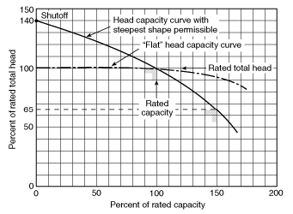

  - If possible, the fire pump should be selected so that the pump discharge pressure is within the allowable pressure range of the pipe. Generally, fire protection piping is rated to 175 psig. If the churn pressure exceeds 175 psig, a relief valve is required. It is possible to design a higher pressure piping system, but pressure regulating valves will be needed for any standpipe or sprinkler zone connections.

Types of Fire Pumps

  - General: The three most common types of fire pumps allowed by NFPA 20 are horizontal split case centrifugal, vertical split case, and vertical turbine fire pumps. Pumps can either be electric or diesel engine driven.

  - Centrifugal Fire Pumps:

    - Horizontal split case fire pumps have the largest selection of sizes and are the most commonly used.

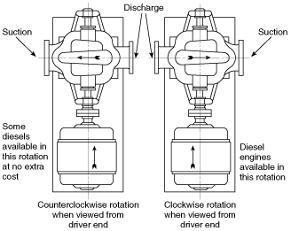

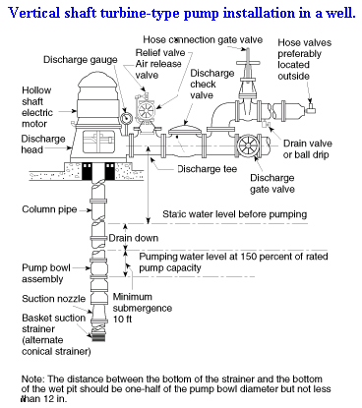

    - Vertical split case fire pumps are used for lower fire flows or when fire pump room space is tight.
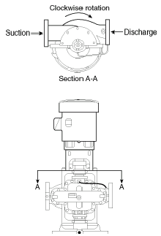

    - Vertical turbine fire pumps are used exclusively for underground suction tank, wet pit pond intake, and well installations.

  - Jockey Pumps:

    - A jockey pump is used to maintain constant pressure in the fire protection system. The primary reason for installing a jockey pump is to prevent cycling of the larger fire pump to maintain pressure.

  - Electric and Diesel Engine Drivers

    - Pump driver selection is generally based on availability and reliability of electric power and based on total installed cost.

    - NFPA does not explicitly require a back-up emergency generator for electric driven fire pumps, but AHJ’s will require it if the power supply is not considered reliable. Typically, a separate electric feed prior to the building service is considered reliable. If a large generator is already being installed on the project, it’s still good practice to connect the fire pump with a transfer switch.

    - If an electric fire pump will have a negative cost impact on the electric service or generator sizing, it is common to see a diesel driven fire pump.

  - Fire Pump Controls

    - General: Fire pump controllers must be listed for their intended use. If emergency power is supplied to the fire pump, the transfer switch is generally integral to the fire pump controller. The fire pump supplier must provide the fire pump, controller, and any transfer switch.

    - Electric Starters: Across-the-line and several types of reduced voltage starters are available. Starter type should be coordinated with the electrical engineer. A medium voltage fire pump may be a good option to reduce the motor in-rush for higher horsepower motors. However, medium voltage transfer switches are very expensive.

    - Variable Speed Controllers: The 2003 edition to NFPA 20 does not allow pressure regulation with a discharge relief valve. The best solution to prevent system overpressure is to use a variable speed fire pump controller.
    - Pressure Switches: Fire pumps are started based on a water pressure switch inside the fire pump controller.

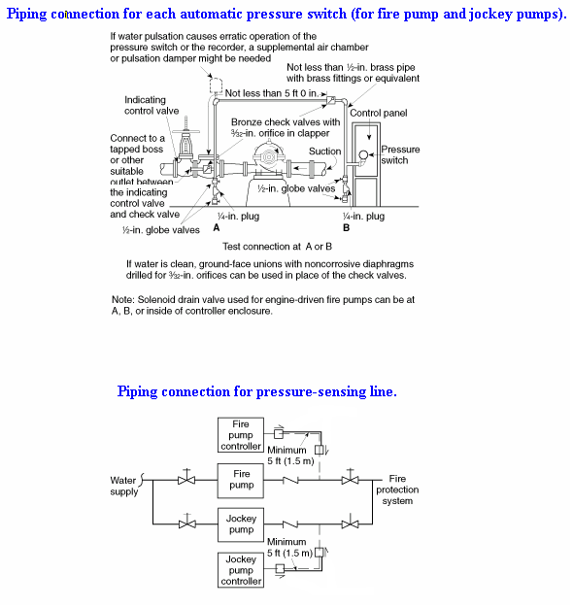

Fire Pump Suction Tanks:

  - Low City Main Residual Pressure: A suction tank is required if there is potential for the fire pump to draw the pressure in the city water main too low. Generally, 20 psig is the minimum pressure allowed by the EPA, the municipal water department, and the AHJ. The residual water main pressure must be checked at the code required 150% rated flow condition. The 2003 edition to NFPA 20 gives the AHJ the authority to require a fire pump discharge regulating valve that regulates to maintain a minimum suction pressure.

  - Reliability of City Water: A suction tank should be considered when the city water main is considered unreliable or when an Owner wishes to maintain building occupancy during a water outage. A Fire Marshal may not allow a building to be occupied if water isn’t available, especially in high-rise buildings. The City of Des Moines lost city water during the flood of 1993. The Fire Marshal did not allow buildings to be occupied above the third floor.

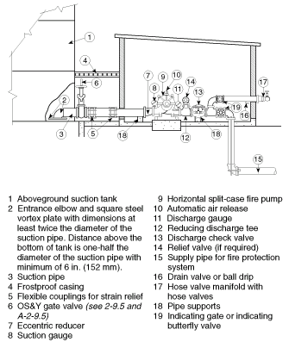

PART 6 - Other Fire Protection items

Elevator Requirements:

It is always good practice to contact the local fire marshal and/or elevator inspector in determining local requirements for sprinklering an elevator hoistway and elevator machine room.

  - Elevator Hoistways

    - Sidewall spray sprinklers shall be installed at the bottom of each elevator hoistway not more than 2 ft (0.61 m) above the floor of the pit.
      - Exception: For enclosed, noncombustible elevator shafts that do not contain combustible hydraulic fluids, the sprinklers at the bottom of the shaft are not required.

    - The sprinklers in the pit are intended to protect against fires caused by debris, which can accumulate over time. Ideally, the sprinklers should be located near the side of the pit below the elevator doors, where most debris accumulates. However, care should be taken that the sprinkler location does not interfere with the elevator toe guard, which extends below the face of the door opening. ANSI 17.1, Safety Code for Elevators and Escalators, allows the sprinklers within 2 ft (0.65 m) of the bottom of the pit to be exempted from the special arrangements of inhibiting water flow until elevator recall has occurred.

    - Upright or pendent spray sprinklers shall be installed at the top of elevator hoistways.
      - Exception: Sprinklers are not required at the tops of noncombustible hoistways of passenger elevators with car enclosure materials that meet the requirements of ANSI.

    - Automatic sprinklers at the tops of hoistways shall be of ordinary- or intermediate-temperature rating.

    - Coordinate the sprinkler temperature rating with the heat detector.

  - Elevator Machine Rooms

    - Automatic sprinklers in elevator machine rooms shall be of ordinary- or intermediate-temperature rating.

    - Coordinate the sprinkler temperature rating with the heat detector.

Electrical Coordination:

  - Electrical monitoring locations

    - The fire alarm panel needs to monitor certain points in the fire protection system. You will need to inform the electrical engineer of the locations of these pieces of equipment. Some of these points might include:

      - Indicator Post monitor switch
      - Monitor switches on miscellaneous shut-off valves, for example, the gate valves on the main Back Flow Preventer or other shut-off valves near the water entrance.
      - Fire Pump (w/controller)
      - Jockey Pump (w/controller)
      - Flow Switches
      - Air Supervisory Switch
      - Pressure Switch
      - Preaction or Clean Agent Release Panel

  - Electrical Power Connections

    - The Electrical Engineer will need to provide power to certain pieces of fire protection equipment. You will need to inform the electrical engineer of the locations of these pieces of equipment. Some of these pieces of equipment might be:

      - Fire Pump (w/controller)
      - Jockey Pump (w/controller)
      - Electric Bell
      - Maintenance air compressor
      - Preaction or Clean Agent Release Panel

  - Elevator Requirements

    - The ANSI Safety Code for Elevators and Escalators requires the shutdown of power to the elevator upon or prior to the application of water in elevator machine rooms or hoistways. Bottom line: If there is an elevator on your project, inform the Electrical Engineer about sprinklering the elevator hoistway or elevator machine room due to requirements involving electrical shunt trips and monitoring devices for elevator operation during a fire situation.

Chemical Agent Fire Suppression

  - Carbon Dioxide (NFPA 12 - Standard on Carbon Dioxide Extinguishing Systems)

    - Carbon dioxide is a colorless, odorless, electrically nonconductive inert gas that is a suitable medium for extinguishing fires. Liquid carbon dioxide forms solid dry ice (“snow”) when released directly into the atmosphere. Carbon dioxide gas is 1.5 times heavier than air. Carbon dioxide extinguishes fire by reducing the concentrations of oxygen, the vapor phase of the fuel, or both in the air to the point where combustion stops.

    - For fire-extinguishing applications, carbon dioxide has a number of desirable properties. It is non-corrosive, non-damaging, and leaves no residue to clean up after the fire. It provides its own pressure for discharge through pipes and nozzles. Because it is a gas, it will penetrate and spread to all parts of a hazard. It will not conduct electricity and can therefore be used on live electrical hazards. It can effectively be used on practically all combustible materials except for a few active metals and metal hydrides, and materials such as cellulose nitrate, which contain available oxygen.

    - The discharge of carbon dioxide in fire-extinguishing concentration creates serious hazards to personnel. In any use of carbon dioxide, consideration shall be given to the possibility that personnel could be trapped in or enter into an atmosphere made hazardous by a carbon dioxide discharge. Suitable safeguards shall be provided to ensure prompt evacuation, to prevent entry into such atmospheres, and to provide means for prompt rescue of any trapped personnel. Consideration shall also be given to the possibility of carbon dioxide drifting and settling into adjacent places outside of the protected space and to where the carbon dioxide can migrate or collect in the event of a discharge from a safety relief device of a storage container. Carbon dioxide systems are most effective for small “table” fires. Do not use for total room flooding applications.

    - Carbon dioxide systems are more economical than other chemical fire suppression systems, but they are larger and require more floor space for the cylinders and components. Still considerably more expensive than conventional fire protection systems.

  - Halon 1301 (NFPA 12A - Standard on Halon 1301 Fire Extinguishing Systems)

    - Halon 1301 (bromotrifluoromethane or CBrF₃) is a colorless, odorless, electrically nonconductive gas that is an effective medium for extinguishing fires. Halon 1301 is included in the Montreal Protocol on Substances that Deplete the Ozone Layer signed September 16, 1987. The protocol permits continued availability of halogenated fire extinguishing agents at 1986 production levels through 2004, with a 50% reduction by January 1, 2005 and complete stoppage by January 1, 2010, with the exception of critical applications including some Halons for jet engine fires. In addition, local jurisdictions within some countries (e.g., the EPA in the U.S.) have enacted further rules regulating the production, use, handling, and deposition of this agent. The user of this standard is advised to consult local authorities for current regulations.

  - FM 200 (HFC-227ea: Heptafluoropropane - CF3CHFCF3 ) is a colorless, odorless, electrically nonconductive gas that is an effective medium for extinguishing fires.
    - Arguably the leading choice for Halon 1301 fire protection system replacements since the phaseout of production of Halon 1301 toward the end of 1993.
    - A FM 200 system is a “high-value asset” fire protection system similar to a Halon 1301 system in that it can be used in occupied and unoccupied spaces and with minimal resulting byproducts during system discharge
    - FM-200 does not contribute to the depletion of the ozone layer, as in Halon 1301 systems.
    - FM-200 systems are more expensive then other chemical fire suppression systems, but they are smaller and require less floor space for the cylinders and components. Considerably more expensive than conventional water based fire protection systems.
    - Typical hazards in which FM-200 should and should not be used are similar to Halon 1301 systems.
    - FM 200 is a patented product produced by Great Lakes Chemical. Other manufacturers produce similar products, for example FE-25 (HFC-125).

